MCG2101 – Intro Design of MCG Systems

Deliverable 6
Group 13

Names:
Haneen Barghouti
Lara Al Nakeeb
Emma Cochran
Linh Nguyen
Toshio Woo

Table of Contents
Table of Figures 2
1. Progress Report 3
1.1 Locomotion 3
1.2. Sampling Mechanism 6
1.3. Buoyancy System 10
1.4. Structure and Wear Resistance 12
1.5. Stability System 13
1.6. Assembly 15
2. References 16

Table of Figures
Figure 1 ………………………………………………………………………………………… 3
Figure 2 ………………………………………………………………………………………… 3
Figure 3 ………………………………………………………………………………………… 4
Figure 4 ………………………………………………………………………………………… 5
Figure 5 ………………………………………………………………………………………… 6
Figure 6 ………………………………………………………………………………………… 7
Figure 7 ………………………………………………………………………………………… 8
Figure 8 ……………………………………………………………………………………… 10
Figure 9 ……………………………………………………………………………………… 12
Figure 10 ………………………………………………………………………………………. 15
Figure 11 ……………………………………………………………………………………… 15
Figure 12 ………………………………………………………………………………………. 15

Progress Report

1.1 Locomotion
In order to prepare the locomotion subsystem for Deliverable 6, many significant changes and improvements were made including improvements to the leg design, the addition of a motor, shafts, a turning mechanism, and an attachment to the crab shell.
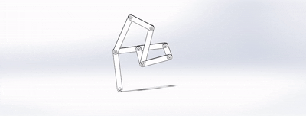
Figure 1. Animation of Klann Linkage Motion
The first change that was made was a return to the single leg design for the Klann mechanism. This change was made to preserve the space inside the crab for the buoyancy and sampling subsystems and involved splitting the legs and making a mirrored copy for the other side of the crab.
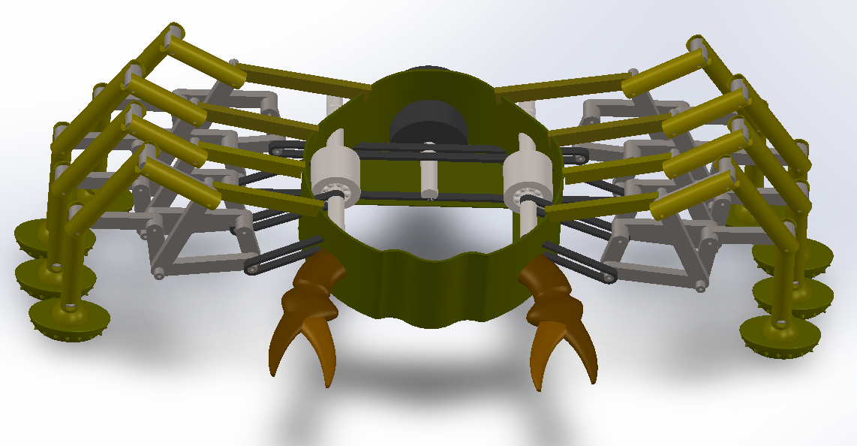
Figure 2. Full assembly & interior
Following this, a system to drive the legs had to be conceptualized and actualized. The most feasable solution was deemed to be a belt drive with multiple shafts with the main goal of preserving space on the interior of the crab. As seen in the figure above, the central shaft is rotated by the motor, driving the other shafts and legs, allowing the integration of a rotational-direction-reversal mechanism which is what allows the crab to turn.
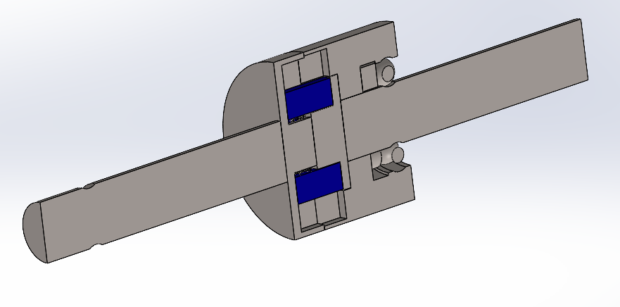
Figure 3. Direction reversal mechanism
The direction-reversal mechanism is a key element of the locomotion design, as it allows the crab to swiftly rotate by adjusting the motor output revolutions per second (RPM). This direction-reversal mechanism works by taking advantage of the centripetal force which acts against springs along a rotating shaft. Inside the mechanism cylinder, there are pins (highlighted in blue) that mesh with mechanisms on the output side of the shaft. When these pins are close to the axis of rotation, they rotate the output shaft directly; however, when the RPM raises, they move away from the axis, meshing with the outer part of the mechanism, engaging the ring gear of a planetary gear. This change reverses the direction of rotation halfway of the front four legs, providing a moment which rotates the crab until the centripetal force decreases again.
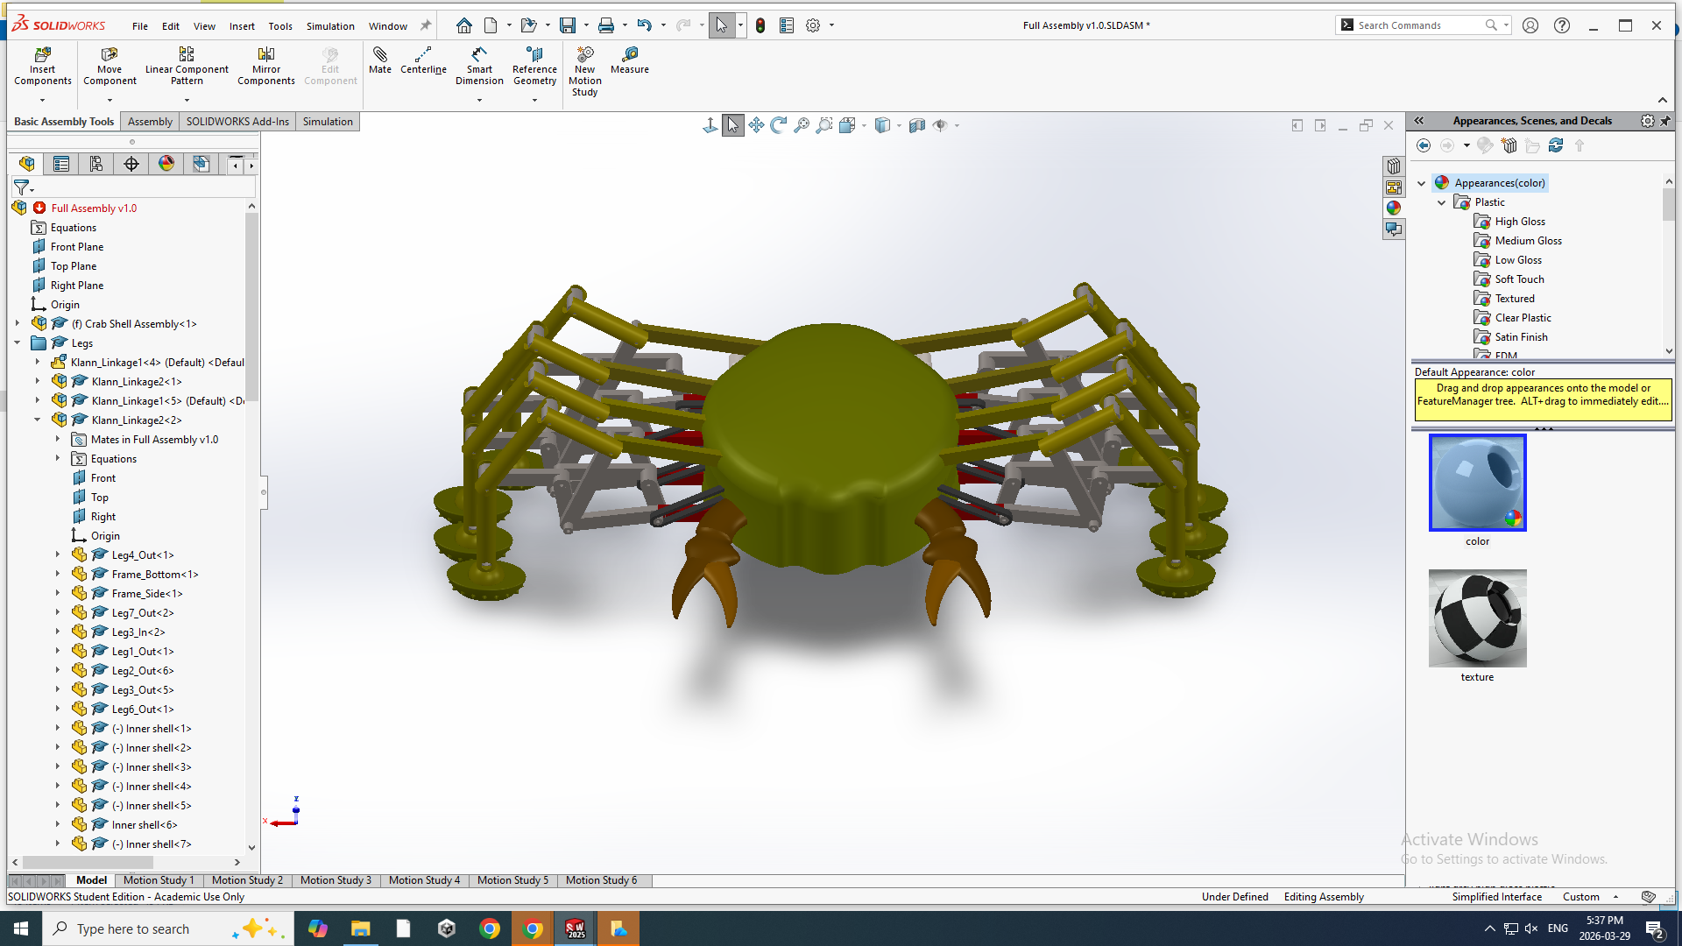
Figure 4. Full assembly with closed shell
Once both the driving method and final leg design was complete, the next step was to attach the legs to the crab. This was done using two connecting beams, one at the top and one at the bottom to ensure structural integrity. Another decision regarding integrity was the decision to use titanium for the legs. Its lightweight, corrosion resistant properties made it a good fit for this design, minimizing the required motor torque, while meeting wear resistance criteria [1].

After determining connections and a driving mechanism, a motor was selected to provide the input rotation to the leg mechanisms. The one selected was the 728-300 – 28mm Brushless Motor. This was chosen for its balance between output torque and size. Providing 55mNm of torque, it is capable of rotating the legs [2]. The required torque was taken by the amount of force to push the leg, multiplied by the radius of the rotating linkage.
$$τ=\left(F_{g}-F_{b}\right)\left(r_{linkage}\right)$$
$$τ=\left(5.84N-2.18N\right)\left(0.0144m\right)$$
$$τ=52mNm$$
In order to finalize the locomotion mechanism there are just a few changes that need to be made. The first change is that cutouts need to be added to remedy the issue of the belts intersecting with the outer shell. The other changes are minor touch-ups, for example, filleting of the internal reversal mechanism to allow smoother motion of the connecting pins so that they won’t stick.

1.2. Sampling Mechanism
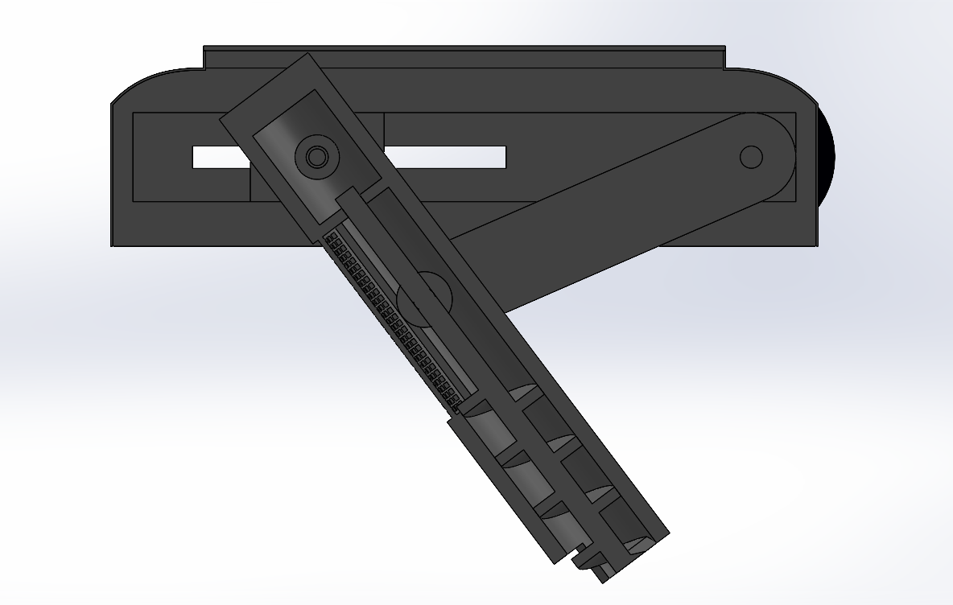
Figure 5. Section view of sampling mechanism assembly
Since the last progress report, a complete SolidWorks assembly for the sampling mechanism was created, see Figure 4 above. The mechanism for turning the screw within the cylinder was again redesigned. The previous design involved two pulleys and two roller guides above the main body of the mechanism to connect the motor shaft to the gears within the screw. This was redesigned to save space above the mechanism to ensure all subsystems would be able to fit within the inner shell. Additionally, this removes the need for a cutout in the cylinder for the belt to enter through, which may have allowed water and sediment to enter and damage the gears within.

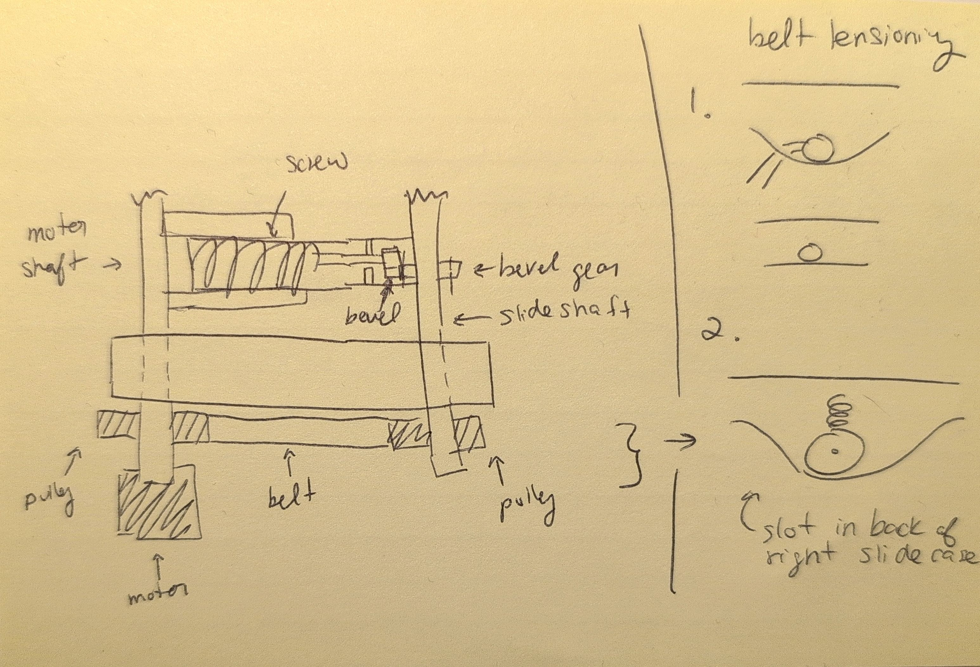
Figure 6. Preliminary sketch of the new belt mechanism to turn the screw
The new mechanism used the shaft already connected to the upper cylinder. It now goes all the way through the cylinder and through one side of the casing. A preliminary sketch of this can be seen in Figure 5 above. Outside the casing, there is a pulley connected to the shaft with a belt around it. This belt also connects to a pulley on the motor shaft. This layout also includes a belt tensioner with two smaller pulleys, moved by a small spring. The non-motor shaft slides as the cylinder moves and has a bevel gear mounted on it. This bevel gear connects to the smaller bevel gear attached to the helix shaft, allowing it to spin. This mechanism can be seen in Figure 6 below.
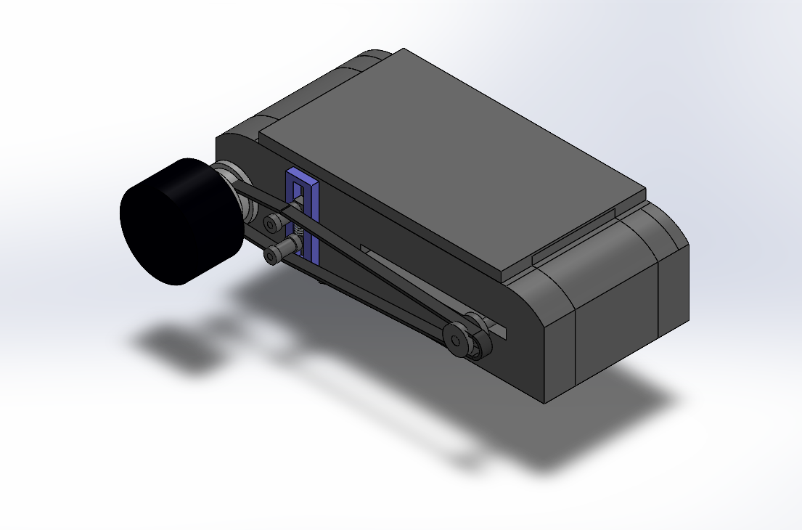
Figure 7. Fully contracted sampling mechanism subassembly
Other smaller changes were also made to the design during the modeling process. The linkage is no longer exactly a Scott-Russell linkage as the bars connecting the motor shaft and the cylinder were lengthened to ensure the cylinder would not hit the motor shaft. This means the cylinder end no longer travels straight down vertically and instead follows a curved path, which is likely better for collecting sediment. Another minor change was the addition of an angled cutout at the bottom of the cylinder to allow sediment to enter through the side. Top and end panels were also created to enclose the main mechanism and minimize water entering the rest of the inner body. Materials were assigned to the parts created high-density polyethylene (HDPE) for most components, stainless steel for the spring, and rubber for the belt. HDPE was chosen due to its saltwater resistance, durability, and relatively low density when compared to metals.
The sampling subassembly has been fully integrated into the full assembly. During the full assembly, rounded cuts were made into the outer casing to allow locomotion components to fit within the shell. This was not found to affect the working of the sampling mechanism. Final steps to complete this mechanism include final material assignments, final torque and gear ratio calculations, and specific motor selection.

1.3. Buoyancy System

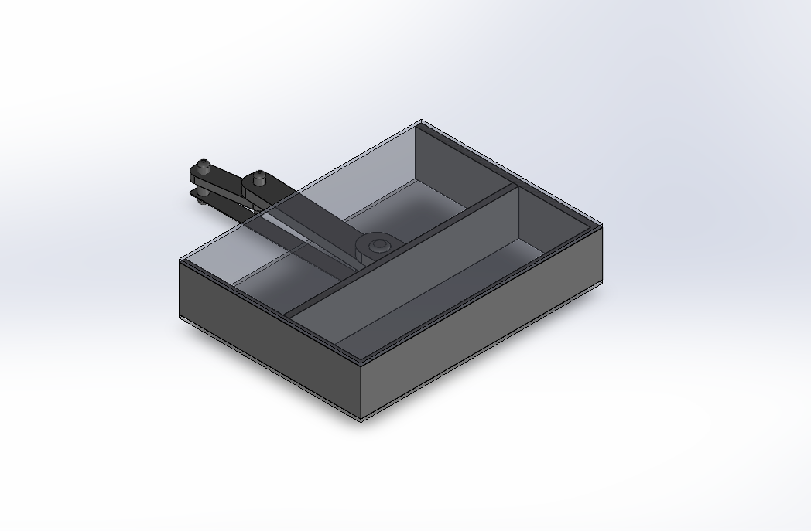
Figure 8. Isometric view of the buoyancy system
In the previous weeks, a buoyancy system was created to ensure the spy crab could have precise vertical control and use minimal energy consumption. Last week the goal was to determine how the piston arm would be driven, and a crank and slider mechanism was chosen to convert rotational motion into linear motion. The motor that drives this crank is placed vertically and no would longer be shared with the motor driving the sampling mechanism. Since there is limited space within the shell, the goal of this week was to optimize the system. This was done by trying to minimize the weight and save as much space a possible. This updated buoyancy system uses a linkage, instead of a cam and connection rod. This was an optimal update as it reduces the amount of material needed and also reduces the weight of the crab. Reducing the weight also helps with decreasing the buoyancy force needed to make the crab rise to the surface. The updated buoyancy system sits nicely in the shell of the crab and does not interfere with the other internal components. The with approximations for simplification the buoyancy force was calculated using the depth at which the crab would operate at, the size of the chamber, and motor force; it was determined that, with the correct materials the buoyancy system would be effective (see buoyancy calculations below).
Buoyancy calculations:
$$F_{B} = ρgV$$
$${F_{B} = \frac{1000kg}{m^{3}}∙9.81m}/{s^{2}∙12862mm^{3}}$$
$$F_{B} = 0.126N$$
The chamber of the crab is quite small due to the size limitations of the crab. Therefore, not as much buoyant force can be provided. To increase this buoyant force and make it more efficient in the future, the chamber size could be increased by reducing the size of other components or by optimizing the arrangement of the other internal components. The SolidWorks model features the buoyancy system with a transparent lid to highlight the internal workings of the mechanism.
Future work for the buoyancy system would include determining the best material vs strength and durability ratio.

1.4. Structure and Wear Resistance
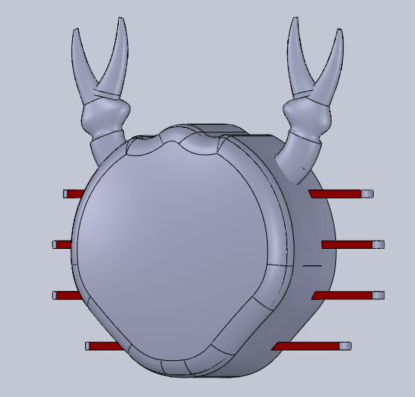
Figure 9. Finalized Crab Shell CAD Model
Significant progress has been made in the development of the crab shell. One of the new add-ons to the shell was a finalized extruded rod to connect the leg linkages to the main shell. These rods serve as structural members that allow loads that are generated during motion to be distributed evenly along the body and legs of the crab. This new addition reduces the deformation at the joints when the crab is on uneven surfaces or reduces any misalignments. A finalized design of the claws was also incorporated into the shell. The claws were added to enhance the realism appearance of the crab.
For material selection we decided to go with HDPE (high-density polyethylene) as it was chosen due to its strong resistance to salt water, therefore, increasing life span and helps not corrode quickly. It doesn’t degrade easily and has good impact toughness. This polymer was also chosen as it is lightweight and doesn’t way down the crab as the crab legs are made of metal. Therefore, in order to minimize the weight of the crab we decided to go with a lightweight but strong polymer.
Overall, the full outer shell design has been completed. The shell acts as a protective barrier for the systems within the shell, for example the buoyancy system and sampling mechanism. It will help shield them from impacts, debris and any prolonged exposure to the water. The completed shell will help to easily distribute the force to reduce stress and improve durability of the system.

1.5. Stability System
The final friction pad design enables stable locomotion on potentially uneven seabed terrain. The pad design is the primary ground-contact of the robot crab. The final configuration consisted of an oval dome pad with surface spikes for traction (See Figure 10 below). The pad is connected to the leg through a ball bearing joint. This functional design is also mechanically simple for manufacturing purposes. This design maximizes stability and contact adapting to uneven terrain and is compatible with the walking motion of the Klann linkage.
Initially the pad was a hemisphere shape, and this was modified to an elliptical dome. This modification was necessary to prevent interference between the legs/foot pads during the walking cycle. The elliptical shape has similar contact area with the ground but has the advantage of smaller width to allow the adjacent legs to pass by each other without hitting one another. Spikes were also added around the centre of the footpad to provide better traction on a sandy or rocky seabed, but the rounded shape reduces disturbance to sediment.
For the connection mechanism to the shell of the leg/linkage, a ball bearing was used instead of a rigid joint. This allows the pad to accommodate the terrain and the movement of the linkage, as well as creating better contact and load distribution. The ball bearing is part of the leg shell giving it a dual purpose as both a joint and a casing for the Klann linkage. This creates protection from debris.
Overall, this design helps the robot crab to meet necessary criteria. The finalized friction pad has a shape that maximizes contact and prevents interference due to the elliptical design and the spikes. The ball bearing joint enables adaptability to the terrain and compatibility with the legs. Integration into shell simplifies the design and enhances durability.

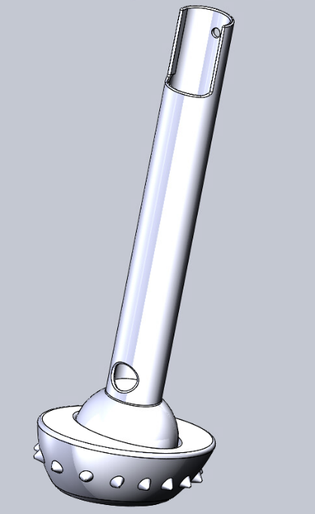
Figure 10. Finalized footpad with integrated leg shell

1.6. Assembly
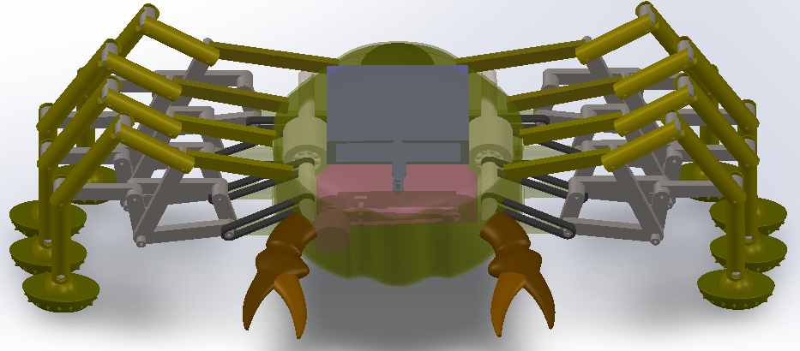
Figure 11 & 12. Full assembly

Overall, much of the progress made in each subsystem was integration into the full assembly. As such, the assembly is a nearly complete model of how the crab will look and function. Once each subsystem had a working prototype, they were combined into the full assembly structure. However, unsurprisingly, they interfered with each other at many points, so required readjustments to allow everything to fit inside the size constraints. One example of a measure taken to allow adequate space was by rounding the corners of the sampling mechanism’s shell to make space for the turning mechanism. Testing of each component inside the crab was done to ensure proper functionality; however, more testing remains to be done to ensure there are no performance issues due to integration.

References
[1] AZoM, “Titanium - Corrosion by Water,” AZoM.com, Feb. 05, 2002. https://www.azom.com/article.aspx?ArticleID=1226 (accessed Mar. 29, 2026).
[2] “728-300 – 28mm Brushless Motor,” Precision Microdrives. https://www.precisionmicrodrives.com/product/728-300-28mm-brushless-motor? (accessed Mar. 29, 2026).

